**Dual F9P documentation and testing**

**Motivation**

The need for a dual-GPS heading system stems from our attempts to fly in the Arctic during Summer 2022. The drone was very finicky to arm for flight, it kept cycling between the green “Ready for flight” (armable) status and the yellow “Not ready” (not armable) status. Once flying it behaved very erratically – would not maintain position in Position Mode, and drifted rather violently laterally until it crashed into a building.

Subsequent logfile analysis revealed the “Magnetometer Innovation Test Ratio” far exceeded acceptable values.

A brief explanation of this test ratio:

In [Kalman filters](https://en.wikipedia.org/wiki/Kalman_filter) which the drone uses for its [state estimation](https://docs.px4.io/v1.12/en/advanced_config/tuning_the_ecl_ekf.html), "innovation" has a particular meaning. Here's a [wiki link](https://en.wikipedia.org/wiki/Innovation_(signal_processing)) about it. It's similar to a residual, it is the difference between the predicted state at a time t and the actual measured state at time t.

The innovation is the difference between the observed value of a variable at time t and the optimal forecast of that value based on information available prior to time t.

In contrast, the residual is the difference between the observed value of a variable at time t and the optimal updated state of that value based on information available till (including) time t.

The drone calculates its magnetometer innovation and then computes a ratio of the innovation to an "acceptable" level. These quantities are expressed in terms of standard deviations. The acceptable level is set via the "mag_gate" parameter (ctrl-f it [here](https://docs.px4.io/main/en/advanced_config/parameter_reference.html)), and is 3 standard deviations by default. The mag ratio should be [0.5 or below at all times](https://mavlink.io/en/messages/common.html#ESTIMATOR_STATUS):

Under normal operation the innovation test ratios should be below 0.5 with occasional values up to 1.0. Values greater than 1.0 should be rare under normal operation and indicate that a measurement has been rejected by the filter. The user should be notified if an innovation test ratio greater than 1.0 is recorded. Notifications for values in the range between 0.5 and 1.0 should be optional and controllable by the user.

So why were our magnetometer errors so high? It turns out that the [magnetic inclination around MARS](https://www.ngdc.noaa.gov/geomag/WMM/image.shtml) is about 88 degrees, ie only 2 degrees off of vertical. That translates to very little signal to the magnetometer. Which motivates the dual GPS system for GPS heading.

Description:

The u-blox F9P GPS module is necessary for dual-GPS heading. Technically the M8P could be used as it supports moving RTK base, but the PX4 firmware would need some hacking to compute the NED components whereas the F9P supplies these components to the FC. We are using two 49g [Holybro helical F9P](https://holybro.com/products/h-rtk-f9p-gnss-series)s:

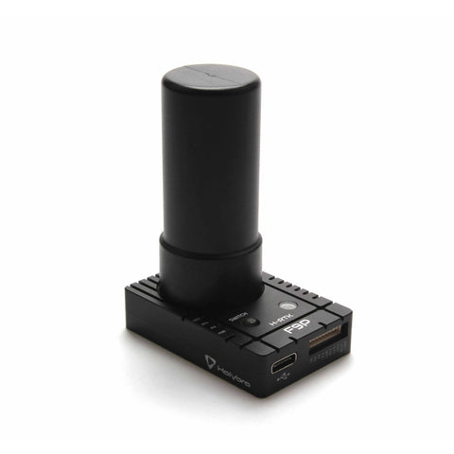

**Dual-F9P system setup**

From [PX4 site](https://docs.px4.io/v1.12/en/gps_compass/u-blox_f9p_heading.html):

Ideally the two antennas should be identical, on the same level/horizontal plane and oriented the same way, and on an identical ground plane size and shape ([Application note (opens new window)](https://www.u-blox.com/sites/default/files/ZED-F9P-MovingBase_AppNote_%28UBX-19009093%29.pdf), section *System Level Considerations*).

* The application note does not state the minimal required separation between modules (50cm has been used in test vehicles running PX4).
* The antennas can be positioned as needed, but the [GPS_YAW_OFFSET](https://docs.px4.io/v1.12/en/advanced_config/parameter_reference.html#GPS_YAW_OFFSET) must be configured: [GPS > Configuration > GPS as Yaw/Heading Source](https://docs.px4.io/v1.12/en/gps_compass/#configuring-gps-as-yaw-heading-source).

In overview:

* The UART2 of the GPS devices need to be connected together (TXD2 of the "Moving Base" to RXD2 of the "Rover")
* Connect UART1 on each of the GPS to (separate) unused UART's on the autopilot, and configure both of them as GPS with baudrate set to Auto. The mapping is as follows:
  + Main GPS = Rover
  + Secondary GPS = Moving Base
* Set [GPS_UBX_MODE](https://docs.px4.io/v1.12/en/advanced_config/parameter_reference.html#GPS_UBX_MODE) to Heading (1)
* [EKF2_AID_MASK](https://docs.px4.io/v1.12/en/advanced_config/parameter_reference.html#EKF2_AID_MASK) parameter bit 7 must be set (see [GPS > Configuration > GPS as Yaw/Heading Source](https://docs.px4.io/v1.12/en/gps_compass/#configuring-gps-as-yaw-heading-source)).
* [GPS_YAW_OFFSET](https://docs.px4.io/v1.12/en/advanced_config/parameter_reference.html#GPS_YAW_OFFSET) may need to be set (see [GPS > Configuration > GPS as Yaw/Heading Source](https://docs.px4.io/v1.12/en/gps_compass/#configuring-gps-as-yaw-heading-source)).
* Reboot and wait until both devices have GPS reception. gps status should then show the Main GPS going into RTK mode, which means the heading angle is available.

**Note**

If using RTK with a fixed base station the secondary GPS will show the RTK state w.r.t. the base station.

In addition to the above parameters, we set the following:

GPS1_config to ‘GPS’

GPS2_config to ‘GPS’

EKF2_mag_type to ‘None’. This removes the magnetometer input from the state estimator.

The heading vector goes from the moving base (connected to GPS 2) to the rover (connected to GPS 1). We have these GPSs aligned back to front, so did not have to configure the GPS_YAW_OFFSET parameter. [Here is a page](https://docs.px4.io/v1.12/en/config/flight_controller_orientation.html#calculating-orientation) I’ve referenced a few times to keep the drone’s reference frame straight in my mind.

**Wiring**

The rover (front GPS) must connect to GPS1. The moving base (rear GPS) must connect to GPS2.

GPS1 on the Cube Orange is an 8-pin port. GPS2 is a 6-pin port.

[Here](https://docs.holybro.com/gps-and-rtk-system/f9p-h-rtk-series/standard-f9p/pinout) is the pinout of the Holybro Helical F9P:

Note that the main GPS (UART1) port is 10 pins. It is really designed for the newer Pixhawk, like the 6X with [the following pinout](https://docs.holybro.com/autopilot/pixhawk-baseboards/pixhawk-baseboard-ports) (perfectly matches the pinout of the Helical):

However, it is [still compatible with](https://docs.holybro.com/gps-and-rtk-system/f9p-h-rtk-series/standard-f9p/h-rtk-with-cube-autopilot) the Cube Orange. Here is the Cube Orange pinout for GPS1 and GPS2:

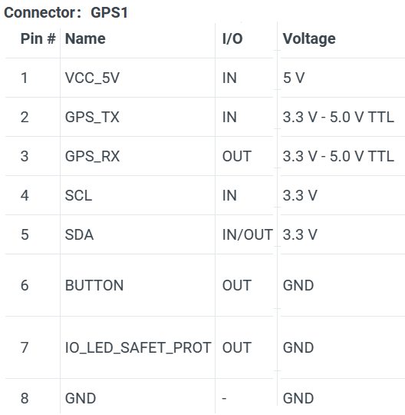 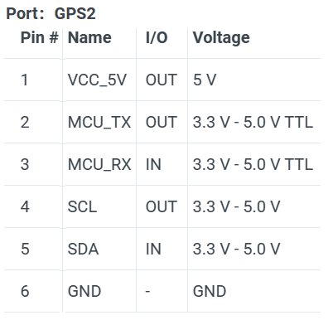

GPS1 port: Wire the matching connectors from the Holybro to the Pixhawk port (pins 1, 2, 3, 4, 5, 10 from the Holybro to pins 1, 2, 3, 4, 5, 8 on the Pixhawk). The integrated safety switch in the Holybro is not designed for the Cube Orange, it is designed for the 5 or 6x with 3.3V TTL. Also, the Cube Orange has no 3.3 VDD pin, and the buzzer is on the USB connector. So, when connecting the 10-pin Holybro line to the 8-pin Pixhawk port, we leave out the pins for safety switch, safety switch LED, 3.3 VDD, and buzzer (pins 6, 7, 8, 9 on the Holybro side). Would be curious to learn about the decision to move the buzzer from USB to GPS1 between the Cube Orange and 5/6x.

To still use the original safety switch, it can be removed from its default connector by carefully removing the crimped pins 6 and 7 (the two black wires) from the connector, and then de-soldering the splice to pin 1 (5V, red wire). We then insert those crimped connectors into the Pixhawk side of our new GPS line from the Holybro at positions 6 and 7, and splice into pin 1. Or, if that is too much trouble, the button can be disabled via the COM_PREARM_MODE parameter.

GPS2 port: The wiring is similar – do not include pins 6, 7, 8, 9 from the Holybro. GPS2 has no pins for the safety switch so it is not a concern.

UART2 ports: both 6 pin ports, create a line from pin 4 (Tx) of the moving base to pin 5 (Rx) of the rover.

For all of the above, the connector type is JST-GH.

**Heading tests on roof**

After setting all the parameters and doing all the wiring, we brought the drone up to the roof for some tests. Comparing to a handheld compass, the dual GPS heading seems very accurate, down to a degree or less. This seems to match up with [the spec from u-blox](https://www.u-blox.com/en/product/zed-f9p-module) (our baseline is about 67cm):

The resolution seems effectively a degree or less as well. The compass swings very smoothly as the drone is rotated; there is still sensor fusion with the IMUs so this is sensible.

If the drone loses the GPS signal, the heading starts to just swing around in a circle at ~1 deg/sec. But, the drone automatically goes into Altitude Hold mode if it loses GPS, so this isn’t a real danger. There is no indication on the Taranis handheld controller when this happens. There is a text and audio alert from QGC on the laptop.

We wanted to verify that the magnetometer is indeed removed from the state estimator via the EKF2_mag_type parameter. To test this, we waved a magnet next to the drone in the default mode without dual GPS for heading and with the magnetometer enabled. The heading did indeed swing around as the magnet was moved around the Cube Orange. We repeated the test with dual GPS enabled and the magnetometer disabled, and the heading gave no response to the magnet. So hopefully the magnetometer is indeed not included in the state estimator at all.

**Hardware mounting**

Likely stemming from the ongoing global supply chain issues, 10mm OD carbon fiber tubing of anything greater than 0.5m length is hard to find, and expensive to ship. The Tarot 680 Ironman frame comes with two 10mm OD x 28cm mounting tubes, meant to be held in place by rubber grommets at either end of the frame. They are intended as a gimbal mountpoint for a device such as a camera system. We repurpose these by pulling them out from the drone by approximately 25cm and fixing them in place with 3D-printed mounting brackets. We then 3D-print some mounting platforms for the two GPS units. We had to make sure the mounting platform lowered them below plane of the prop discs.

Drone with dual GPS mounting system. Also visible are the GPS signal lines, and the red line connecting the UART2 ports of the Holybro Helicals.

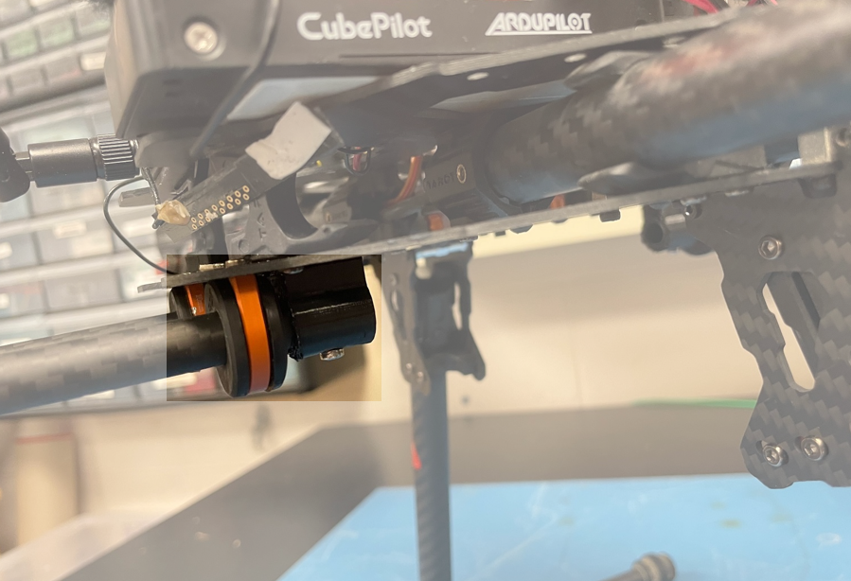

3D-printed mounting bracket for repurposed Tarot CF tubing (highlighted). The rubber grommets are held by the orange metal brackets.

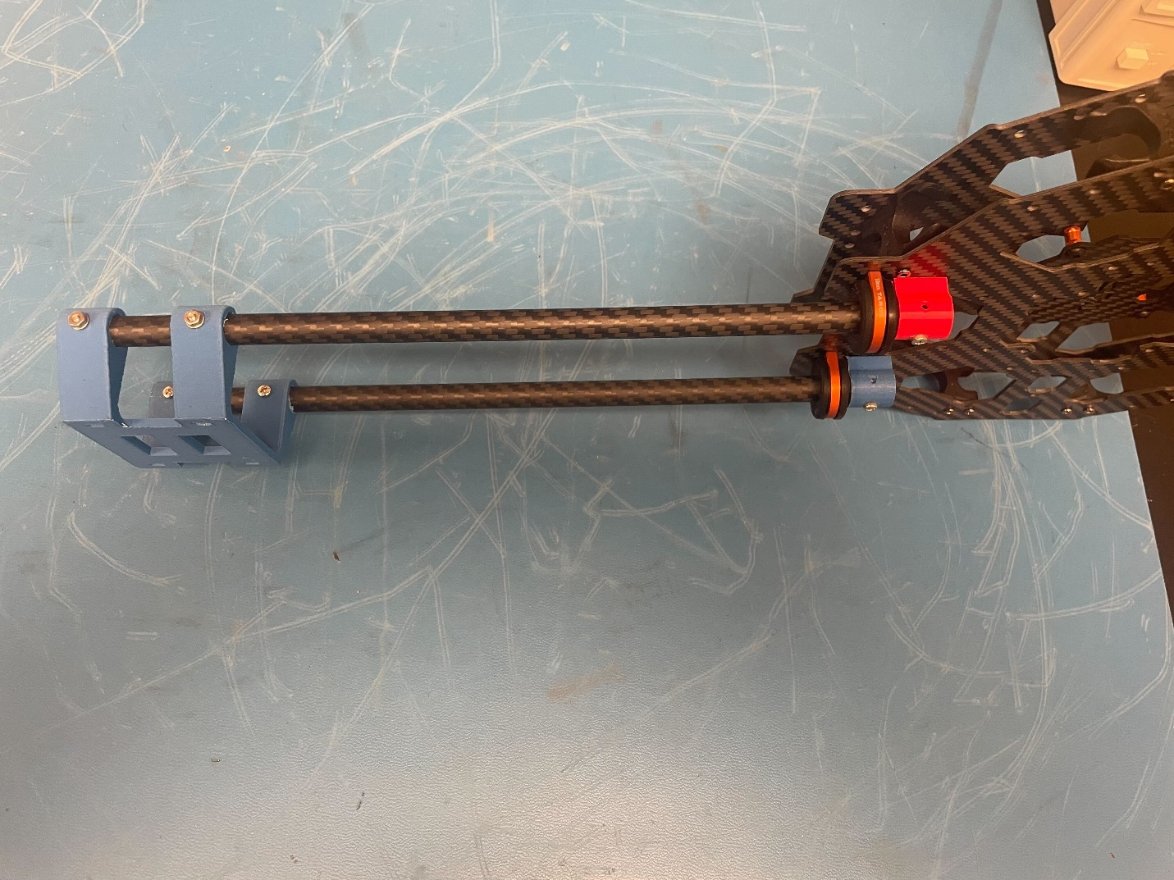

Some test-printed GPS mounting platforms and CF tubing mounting brackets, included for clarity.

**GPS walkaround test for TC**

The GPS walkaround test for lateral accuracy verification occurred on March 27, 2023. Details can be found in the memo “Pos-Alt-Addendum.” The GPS system was found to have an accuracy, to a 95% confidence level, of 2.0 m +/- 1.4 m.

**First Flight**

First flight with the dual-F9P GPS system occurred on March 28, 2023. There were no issues with the drone’s performance – if anything, it seems to fly more stably with the dual GPS system than with the magnetometer (qualitative observation).

Coming in for a landing at the conclusion of the first flight of the dual-GPS system.